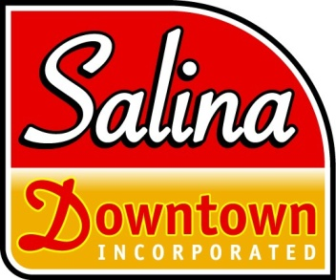
Salina Downtown, Inc
...to champion a healthy, vibrant downtown community!

DEVELOPMENT INCENTIVE PROGRAM
Entertainment Grant Guidelines and Application

GUIDELINES

DIP Entertainment funding promotes cooperative programming of one or more Salina Downtown businesses.

AVAILABLE FUNDS: SDI has a maximum of $3,000 to award on a competitive basis for the remainder of 2019. Minimum single grant request is $50. Maximum single grant request is $200.

MATCHING REQUIREMENT: All applications are competitive and require a minimum cash only match of $1 private investment, per participating business, to $1 Development Incentive Program (DIP) grant funds. In-kind contributions will NOT count towards the required match.

ELIGIBILITY: Any Salina Downtown business in good standing (Service Fees MUST be current), may participate in an application for DIP Entertainment funds. All participating businesses must agree to include the Salina Downtown logo and name recognition in all marketing materials associated with their Entertainment Grant.

Any Salina Downtown business in good standing may participate in one entertainment grant per month (provided funding is available), however preference will be given to first-time grant applicants. Priority will be given to BID dues-paying members.

INELIGIBLE PROJECTS:
- Projects with no minimum 1:1 match
- Applications are NOT accepted from businesses located outside the downtown district.
- Any event initiated prior to the award date.

APPLICATION PERIOD: Applications are accepted monthly (if funds are available).
Application must be made at least 30 days in advance of the event. No events will be considered less than 30 days ahead of the scheduled event.

ELIGIBLE USE OF FUNDS: Entertainment only. Projects may include but are not limited to:
- Buskers
- Bands (indoor and outdoor)
- Acoustic Acts
- Street performers (with proper city approval)
- Plaza performances (must fill out a Plaza use permit through SDI)

DEVELOPMENT INCENTIVE PROGRAM
Entertainment Grant Application

Primary Contact for this application: ____________________________________________________________

Phone: _________________________________ E-mail: ______________________________________________

Mailing address: ______________________________________________________________________________

Salina Downtown Businesses in the event (minimum of 1 eligible businesses)

1.___________________________________ Applicant signature ______________________________

2. __________________________________ Applicant signature ______________________________

TOTAL EVENT COST $__________________

Entertainment Amount Requested $___________________ (Maximum request $200)

Another sponsorship/grant funding request (from SA&H or private donor)? $_________________________

Total Private Match $___________________

Event Name: ___________________________________________________Event Date: __________________

Event time: _______________ Name of performer: ________________________________________________

Who will be billed for the performance: _________________________________________________________

Do you need outdoor electricity turned on? ______________________________________________________

How do you plan to market this performance/event? Be sure to add the Salina Downtown logo and name mention in all advertising. ___________________________________________________________________________________________

___________________________________________________________________________________________

The merchant will oversee paying the performers. After proper proof of the paid performance, SDI will issue a check to the merchant, in the awarded amount, within ten (10) businesses days.

