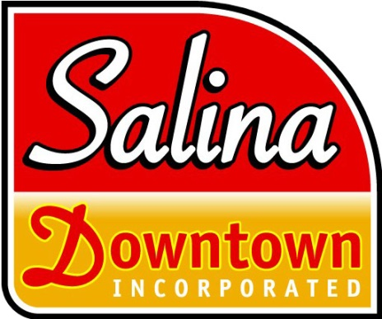

APPLICATION FOR DOWNTOWN PLAZA USE

Application Date Name of Sponsoring Organization

Organization’s Address Phone

Contact Person (person responsible for event) Phone

E-Mail Address Cell Number for Emergencies

Date of Event  **Plaza Requested (Check One):**

_____Campbell, 125 S Santa Fe (Stage & Electrical Available) _____ Phillips Plaza, 126 N Santa Fe

_____ Spillman Plaza, 220 S Santa Fe _____ Strand Plaza, 126 S Santa Fe

# EVENT DETAILS

Kind of Activity Planned:

Hours the Plaza is needed (including set-up and tear-down time):

Electrical needs (include all equipment to be used and amps required for each piece of equipment):

Will you need extra trash receptacles? ____Yes ____No ____Number

Will you need parking spaces barricaded? ____Yes ____No ____Number

Will you need the street barricaded? ____Yes* ____No

***\* If YES, please call the Salina Downtown, Inc. office at 785 825-0535***

Other special needs or requirements:

# USE AGREEMENT

* Electrical equipment for use in the plaza is prohibited unless written approval is obtained from an official with the Salina Business Improvement District No. 1.
* Litter resulting from the event will be removed from the plaza and disposed of properly.
* The Business Improvement District No. 1, Salina Downtown, Inc. and the City of Salina are not responsible for any liabilities relating to this event.

Signature Date

Salina Downtown, Inc. | 120 West Ash | P.O. Box 1065 | Salina, Kansas 67402-1065 | 785.825.0535 T | 785.825.7216 F | **www.salinadowntown.com**